**Product Project**

***Problem Statement***

Essies Ltd is launching a new product and in the initial stage they are targeting some segmented customer and region. David the sales head has just got the new details from the frontline retailers. He has appointed Benson to infer some important insights.

*Creating Date Table for reference*:-

To Create Date table , Go to Home >> Under Query Section go to Advanced Query >> Write the below query to gate Date Function >> Put date range and financial year to get Date table.

**let** fnDateTable = (StartDate **as** date, EndDate **as** date, FYStartMonth **as** number) **as** table =>

**let**

DayCount = Duration.Days(Duration.From(EndDate - StartDate)),

Source = List.Dates(StartDate,DayCount,#duration(1,0,0,0)),

TableFromList = Table.FromList(Source, Splitter.SplitByNothing()),

ChangedType = Table.TransformColumnTypes(TableFromList,{{"Column1", **type** date}}),

RenamedColumns = Table.RenameColumns(ChangedType,{{"Column1", "Date"}}),

InsertYear = Table.AddColumn(RenamedColumns, "Year", each Date.Year([Date]),**type** text),

InsertYearNumber = Table.AddColumn(RenamedColumns, "YearNumber", each Date.Year([Date])),

InsertQuarter = Table.AddColumn(InsertYear, "QuarterOfYear", each Date.QuarterOfYear([Date])),

InsertMonth = Table.AddColumn(InsertQuarter, "MonthOfYear", each Date.Month([Date]), **type** text),

InsertDay = Table.AddColumn(InsertMonth, "DayOfMonth", each Date.Day([Date])),

InsertDayInt = Table.AddColumn(InsertDay, "DateInt", each [Year] * 10000 + [MonthOfYear] * 100 + [DayOfMonth]),

InsertMonthName = Table.AddColumn(InsertDayInt, "MonthName", each Date.ToText([Date], "MMMM"), **type** text),

InsertCalendarMonth = Table.AddColumn(InsertMonthName, "MonthInCalendar", each (**try**(Text.Range([MonthName],0,3)) otherwise [MonthName]) & " " & Number.ToText([Year])),

InsertCalendarQtr = Table.AddColumn(InsertCalendarMonth, "QuarterInCalendar", each "Q" & Number.ToText([QuarterOfYear]) & " " & Number.ToText([Year])),

InsertDayWeek = Table.AddColumn(InsertCalendarQtr, "DayInWeek", each Date.DayOfWeek([Date])),

InsertDayName = Table.AddColumn(InsertDayWeek, "DayOfWeekName", each Date.ToText([Date], "dddd"), **type** text),

InsertWeekEnding = Table.AddColumn(InsertDayName, "WeekEnding", each Date.EndOfWeek([Date]), **type** date),

InsertWeekNumber= Table.AddColumn(InsertWeekEnding, "Week Number", each Date.WeekOfYear([Date])),

InsertMonthnYear = Table.AddColumn(InsertWeekNumber,"MonthnYear", each [Year] * 10000 + [MonthOfYear] * 100),

InsertQuarternYear = Table.AddColumn(InsertMonthnYear,"QuarternYear", each [Year] * 10000 + [QuarterOfYear] * 100),

ChangedType1 = Table.TransformColumnTypes(InsertQuarternYear,{{"QuarternYear", Int64.Type},{"Week Number", Int64.Type},{"Year", **type** text},{"MonthnYear", Int64.Type}, {"DateInt", Int64.Type}, {"DayOfMonth", Int64.Type}, {"MonthOfYear", Int64.Type}, {"QuarterOfYear", Int64.Type}, {"MonthInCalendar", **type** text}, {"QuarterInCalendar", **type** text}, {"DayInWeek", Int64.Type}}),

InsertShortYear = Table.AddColumn(ChangedType1, "ShortYear", each Text.End(Text.From([Year]), 2), **type** text),

AddFY = Table.AddColumn(InsertShortYear, "FY", each "FY"&(**if** [MonthOfYear]>=FYStartMonth then Text.From(Number.From([ShortYear])+1) **else** [ShortYear]))

**in**

AddFY

**in**

fnDateTable

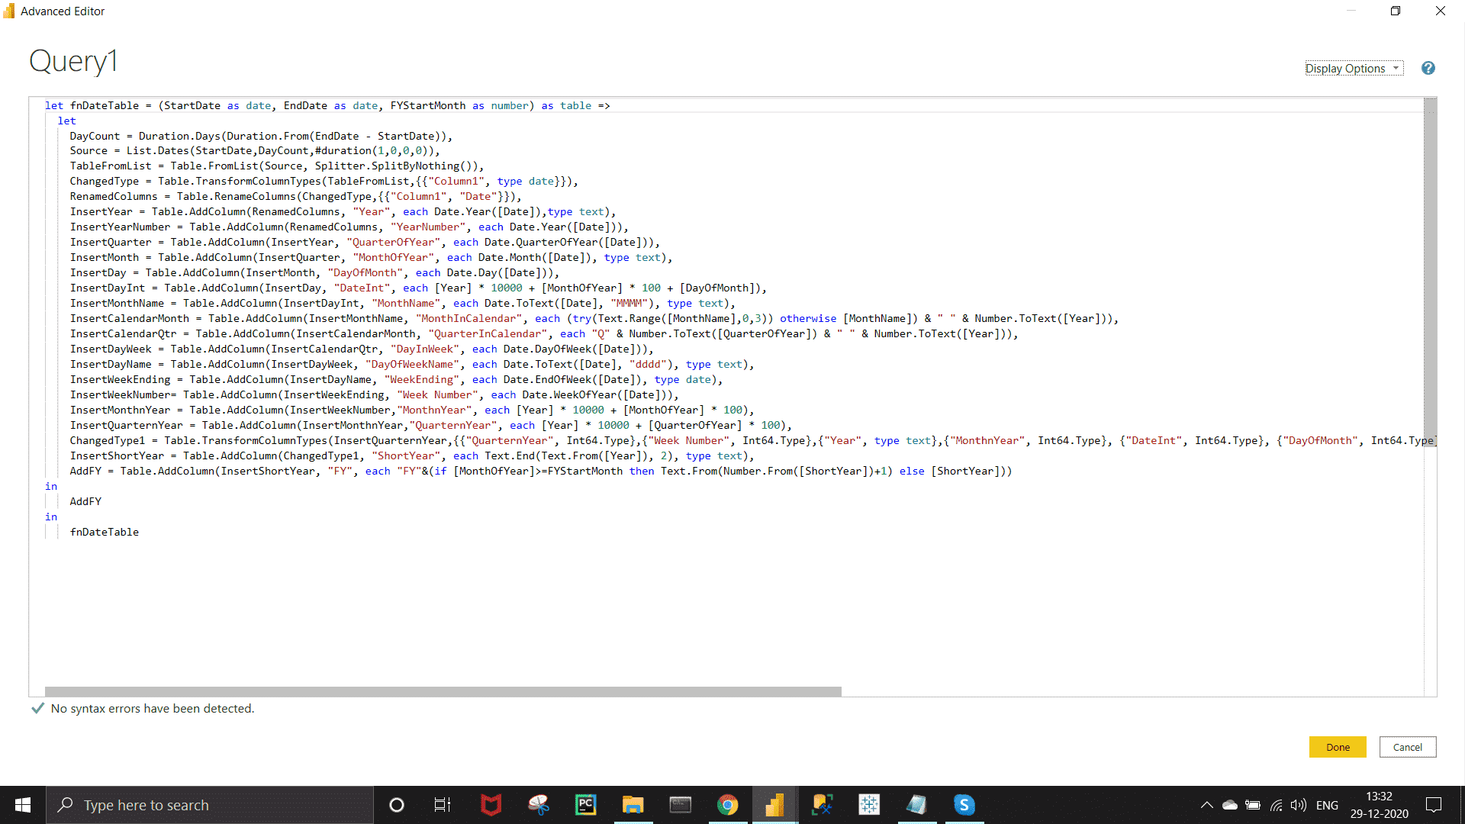

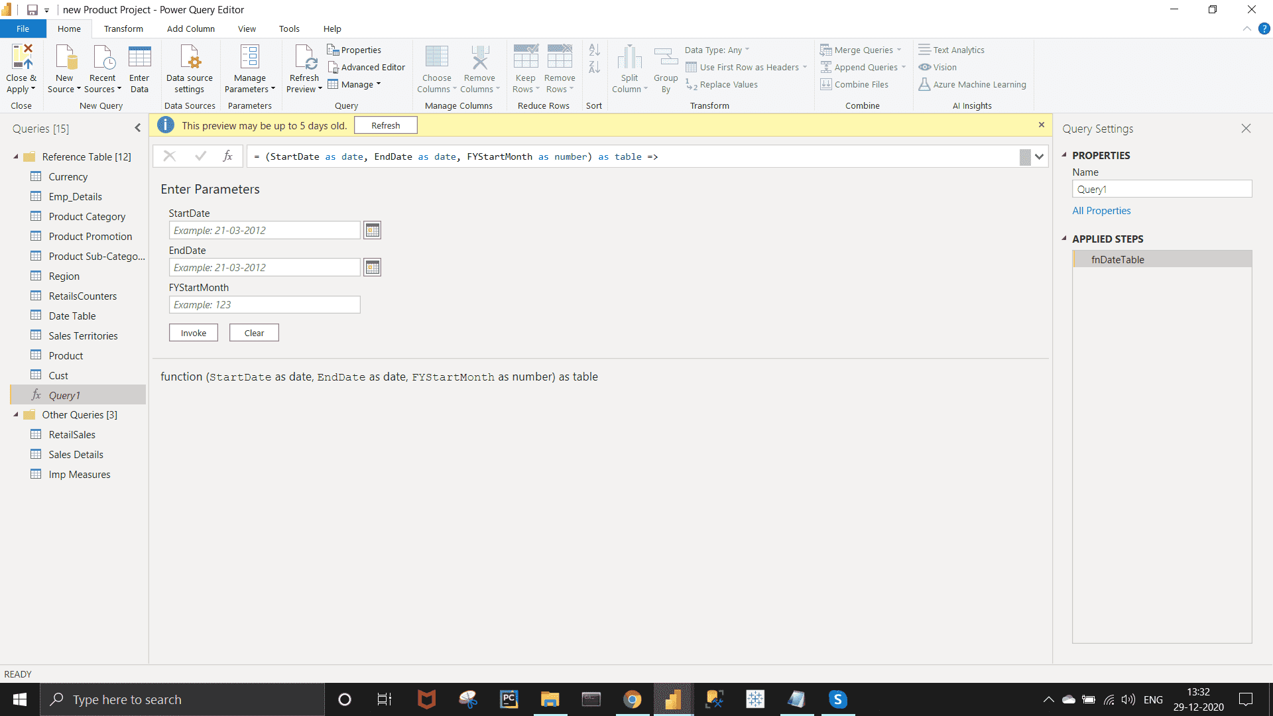

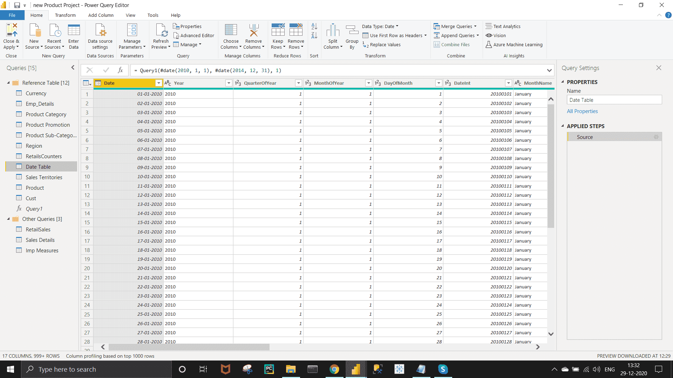

***Data Modeling :-***

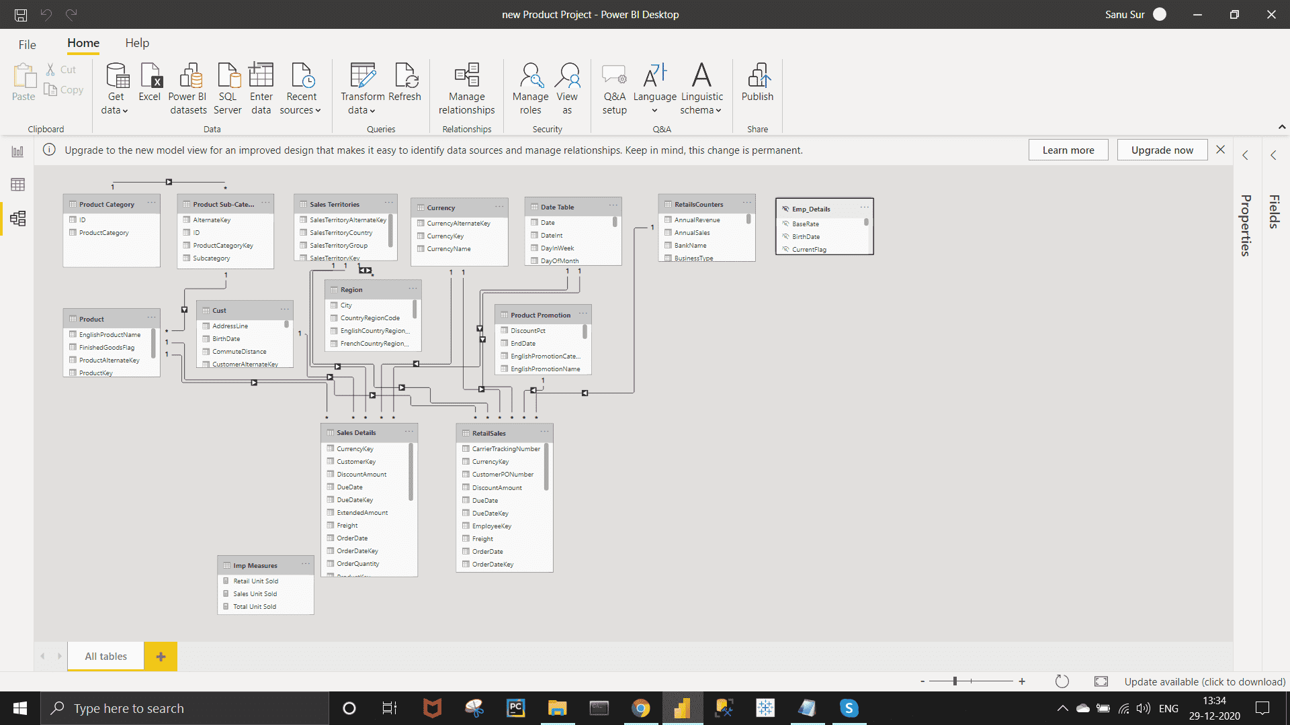

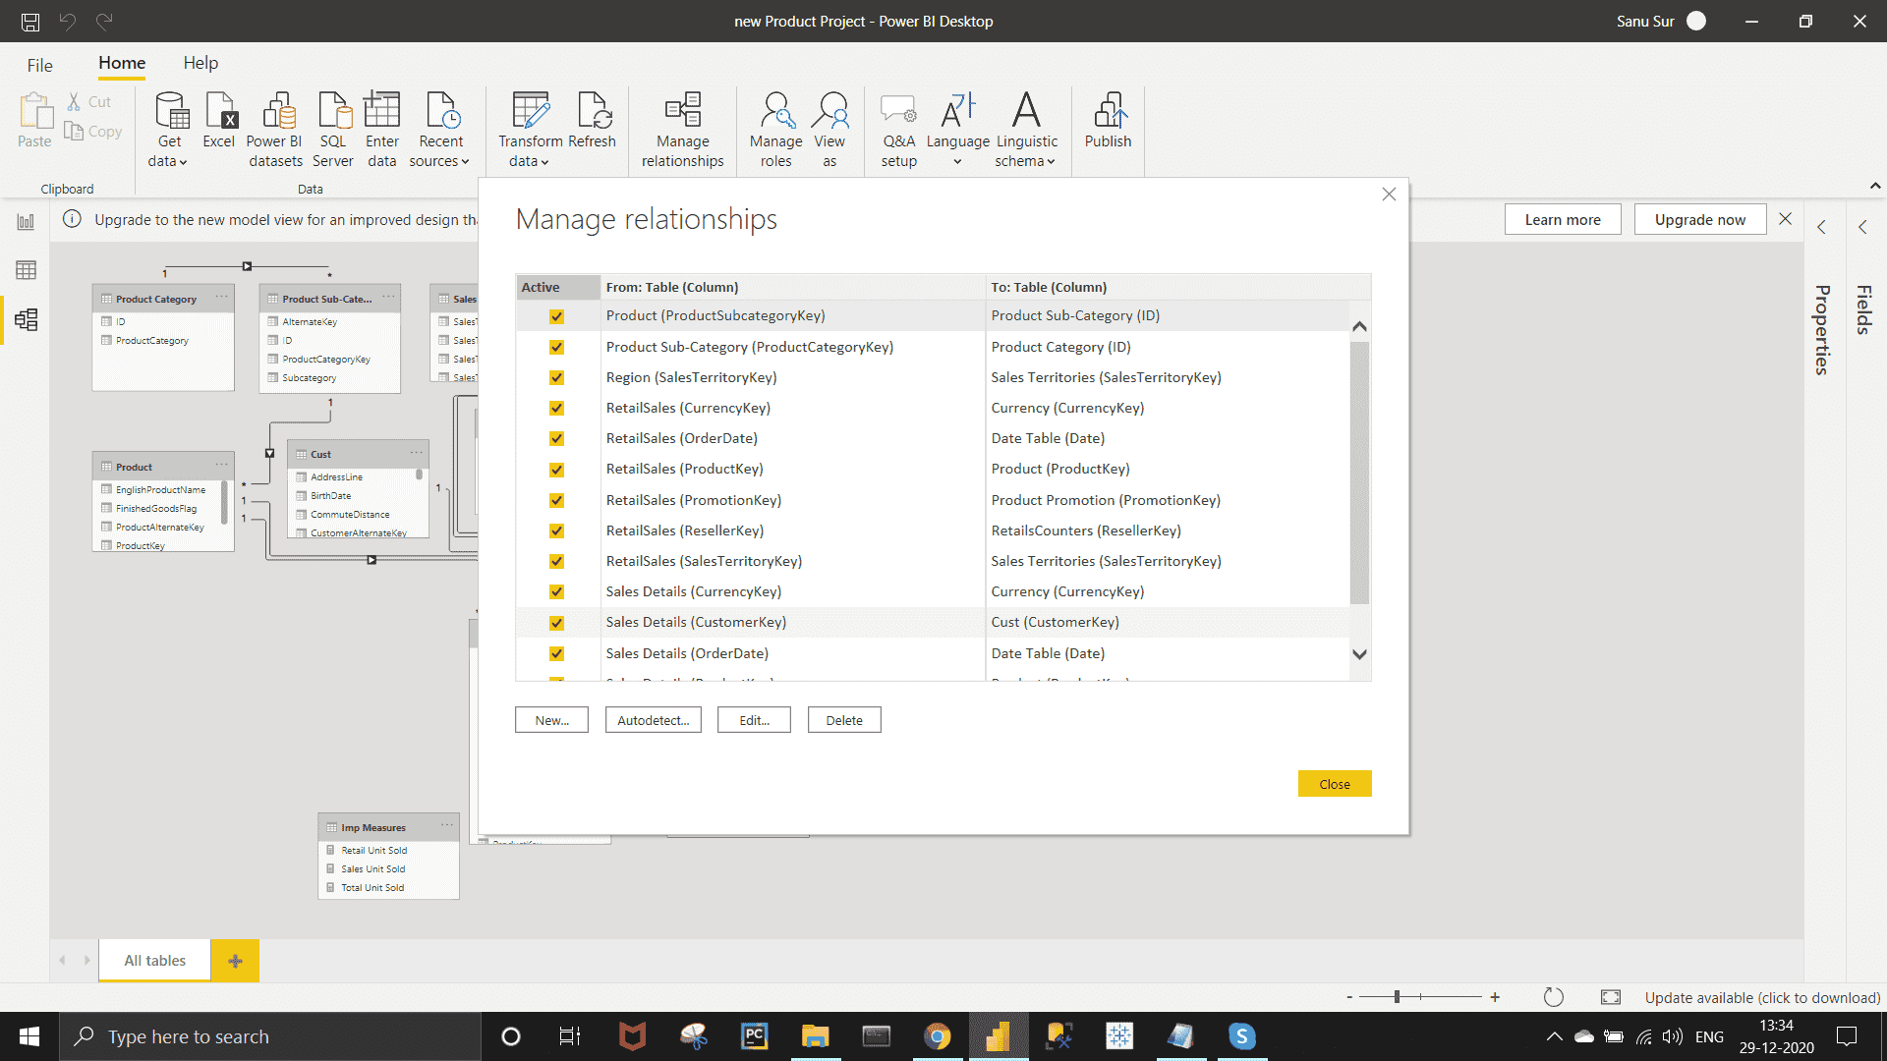

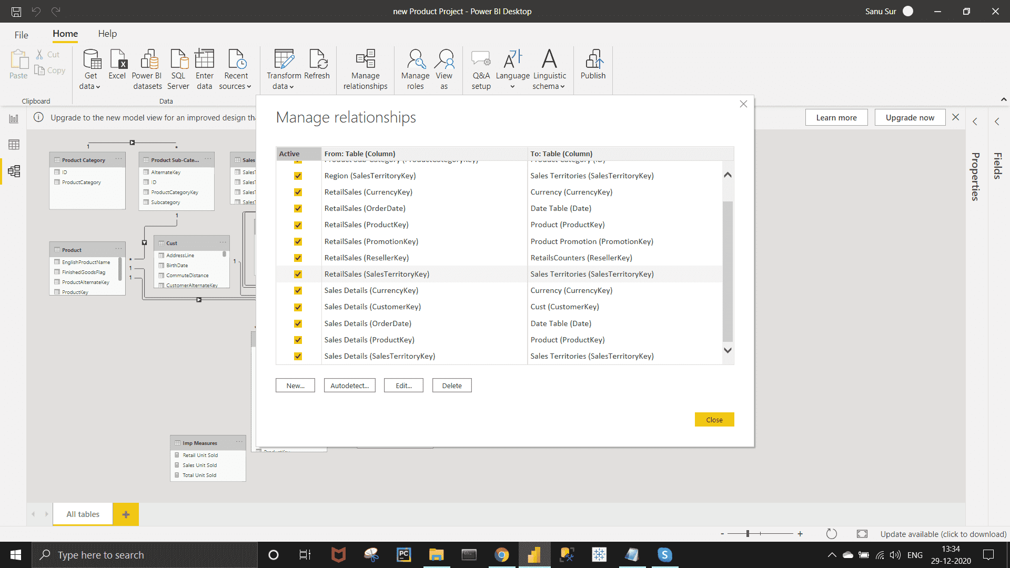

*Requirement :-*

Retails sales needs to have priority in terms of High, Mid & Low.

*Approach :-*

In Power Query Editor, Go to Add column >> Conditional column >>  Fill the required sections as shown in the below image. After this, drag and keep the resulting column beside the SalesAmount column.

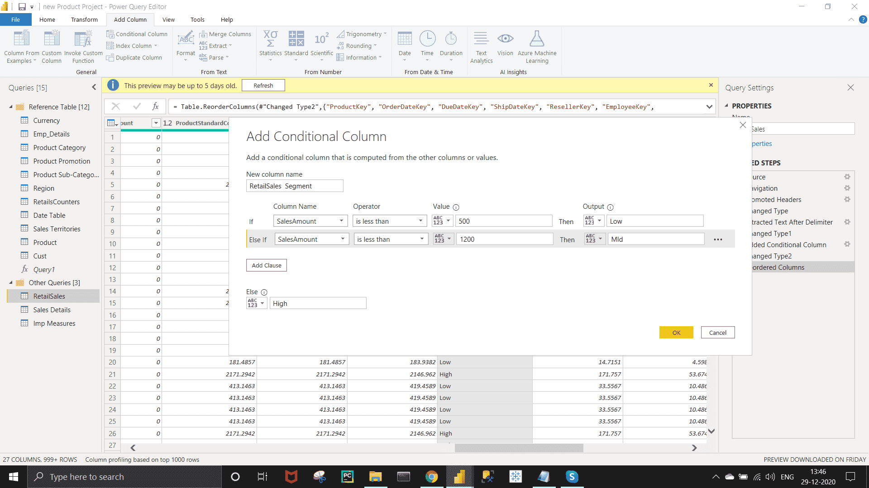

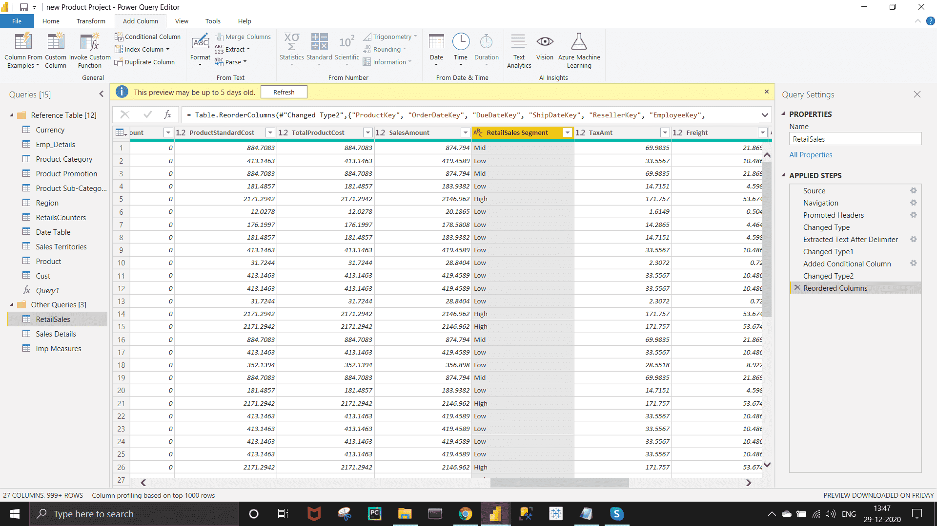

*Requirement :-*

• David needs to have Interactive slicer in terms of Country Flag in the report.

*Approach :-*

For this we need to import  'Enlighten World Flag Slicer' chart by following same steps as shown in the previous 'Student Spent Project' .

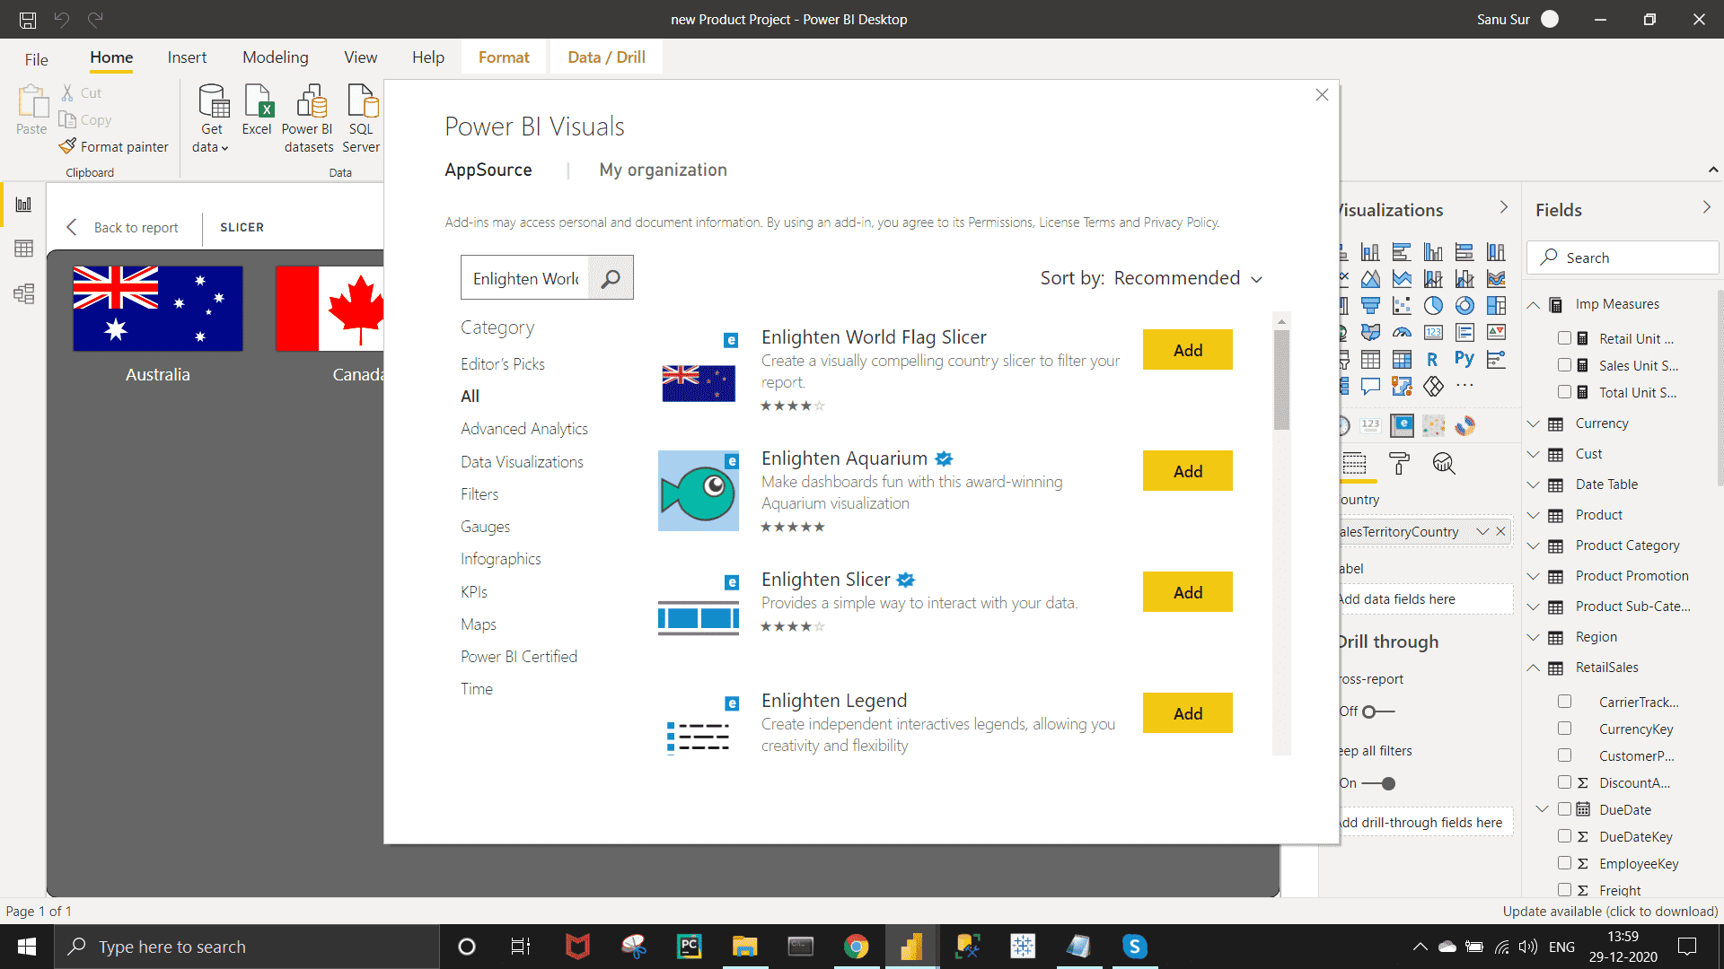

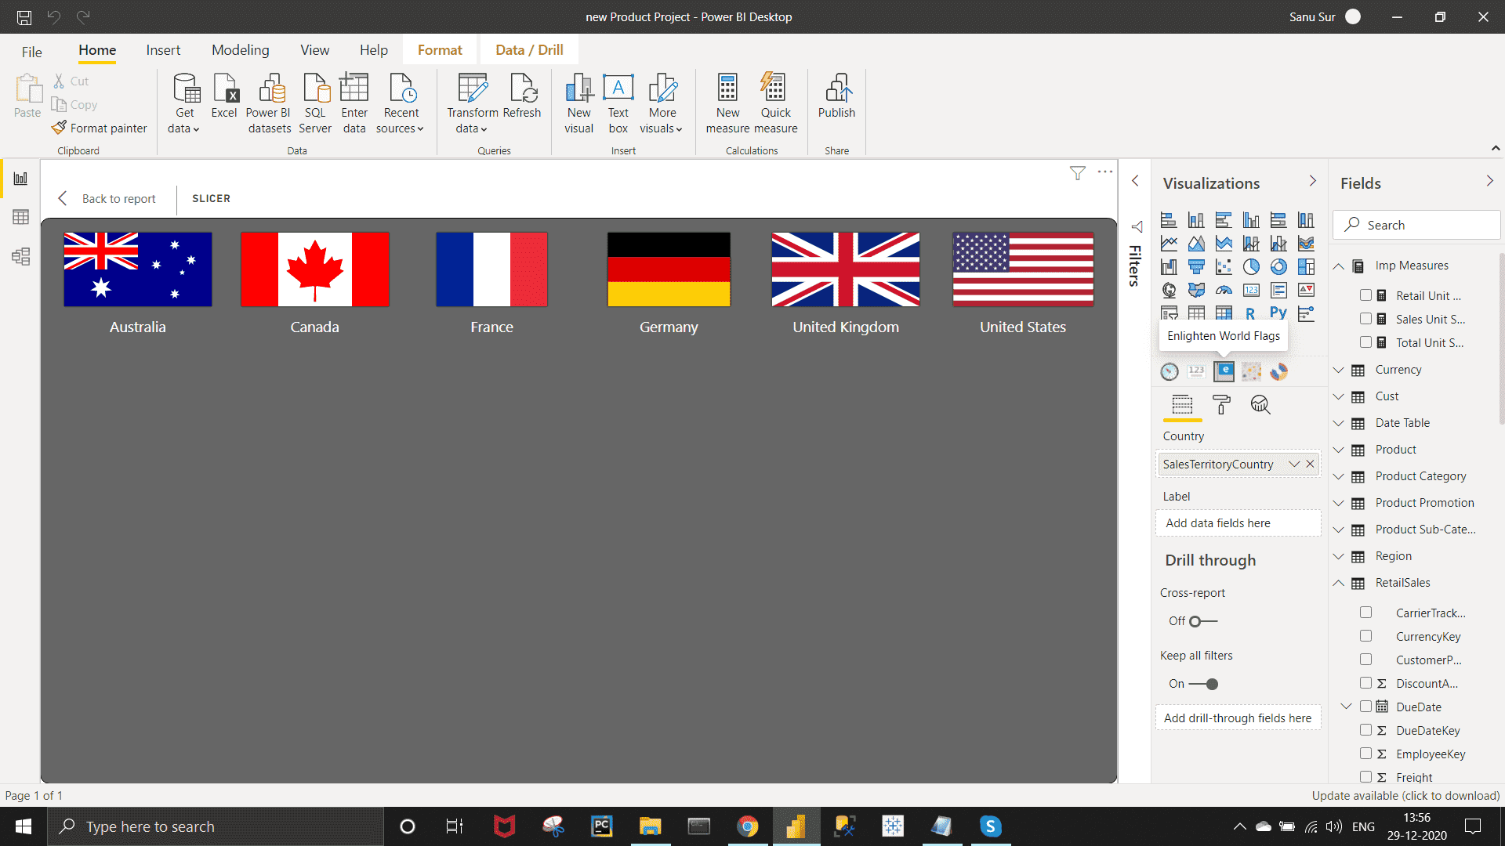

*Requirement :-*

• Essies Dashboard needs to highlight the following:-

o Units Sold by Category

o Total Unit sold

o Retail Unit Sold

o Sales Unit Sold

*Approach :-*

*Calculating  Measures :  Retail Unit Sold , Sales Unit Sold , Total Unit Sold Using DAX formulas given below.*

Retail Unit Sold = sum(RetailSales[OrderQuantity])

Sales Unit Sold = SUM('Sales Details'[OrderQuantity])

Total Unit Sold = [Retail Unit Sold]+[Sales Unit Sold]

To show Unit Sales By Category I have created a Treemap shown below with required fields . Bring ProductCategory to Group and Total Unit Sold Under the Value in field section of visualization field.

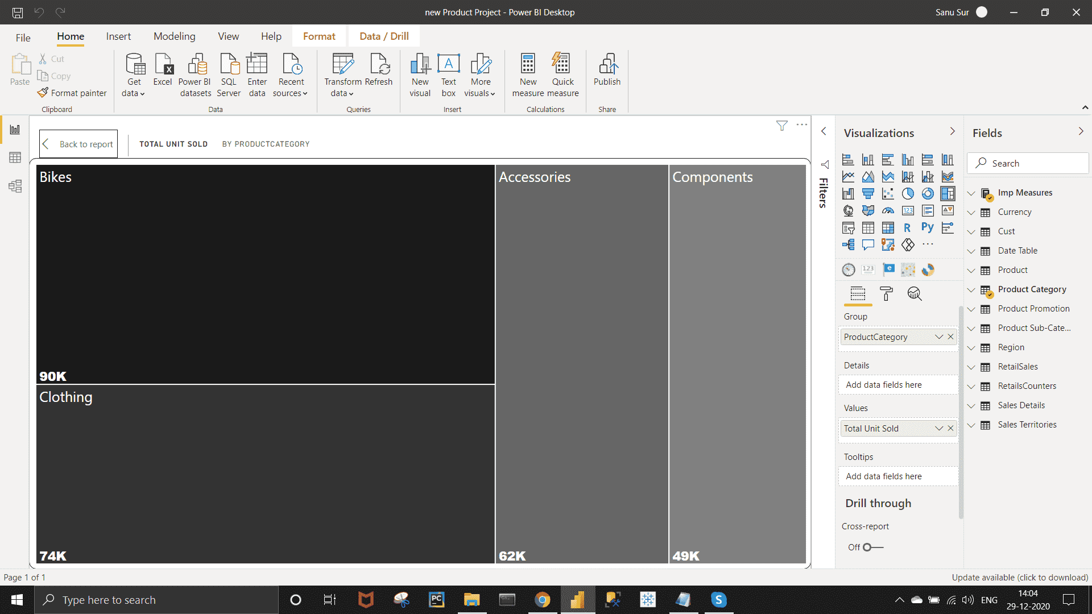

*Requirement :-*

Among all the new Retailer top 10 should be highlighted in terms of unit sold.

*Approach :-*

Create a Clustered Bar Chart >> Bring Reseller Name Name to Axis field and Retail Sales Unit Under Value field under Visualization pen.  
Now Under Filter Pen,  Under Filter on Visual Select filter type as Top N >> Under show item select Top and 10 >> Bring Retail Unit Sold Under Under By Value section >> click on Apply Filter.

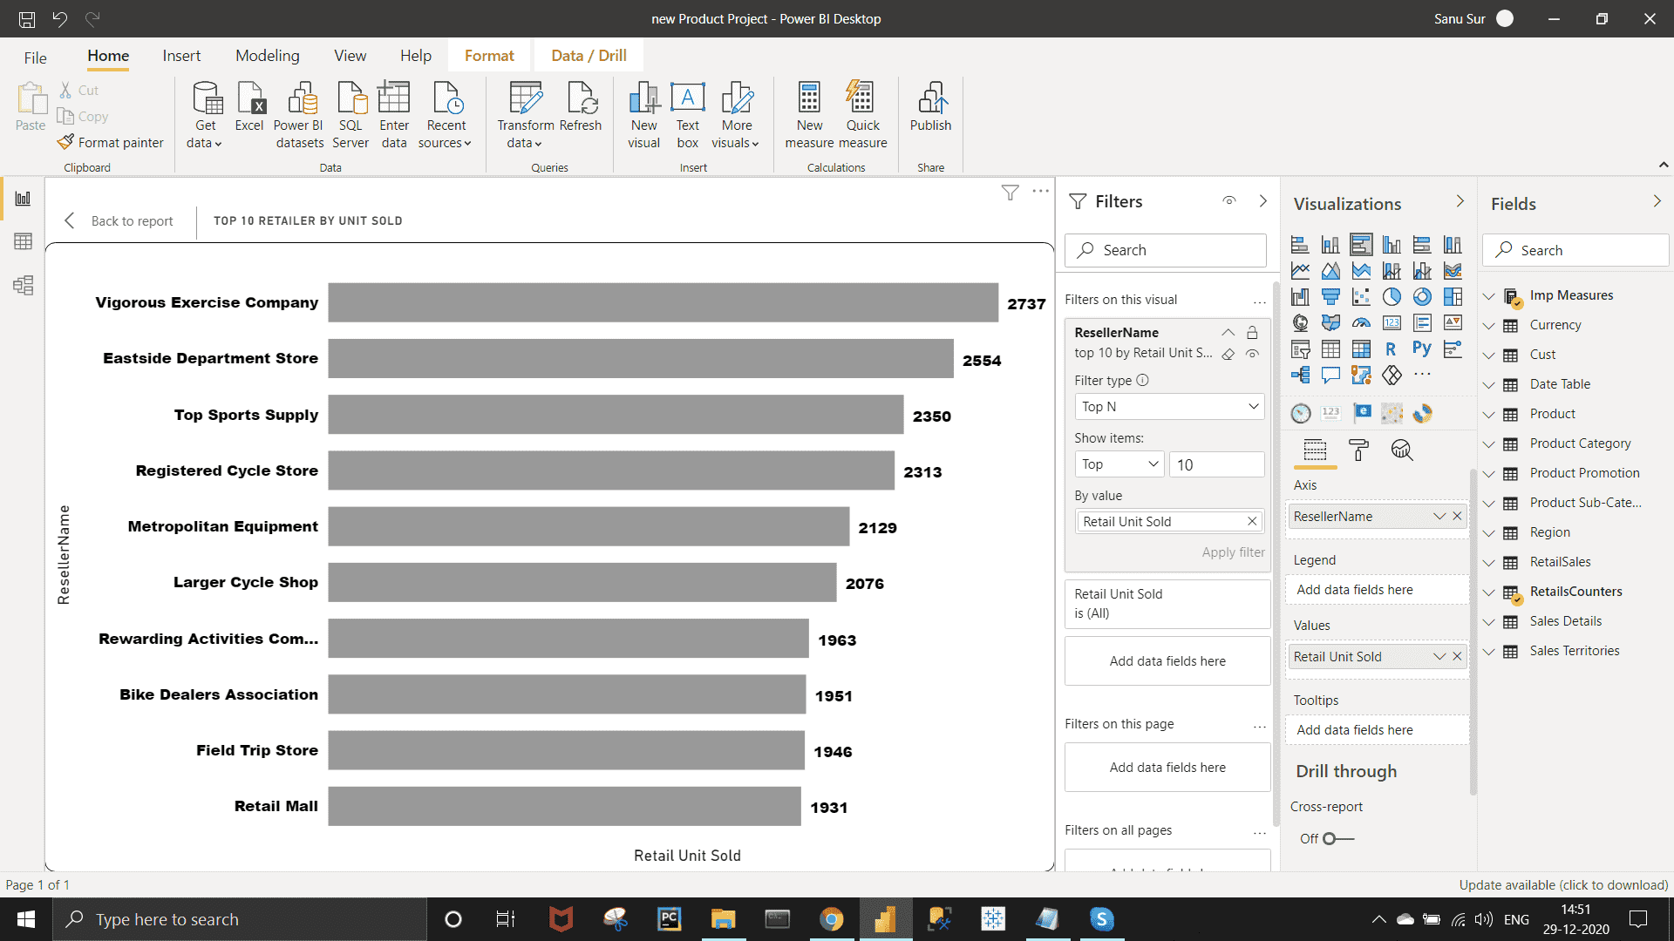

*Requirement :-*

Top performing products in terms of Unit sold

*Approach :-*

Create Table Chart >> Bring English Product Name & Total Unit Sold under Value field >> Short the Total Unit Sold from the visual and arrange the Total Unit Sold in descending order.

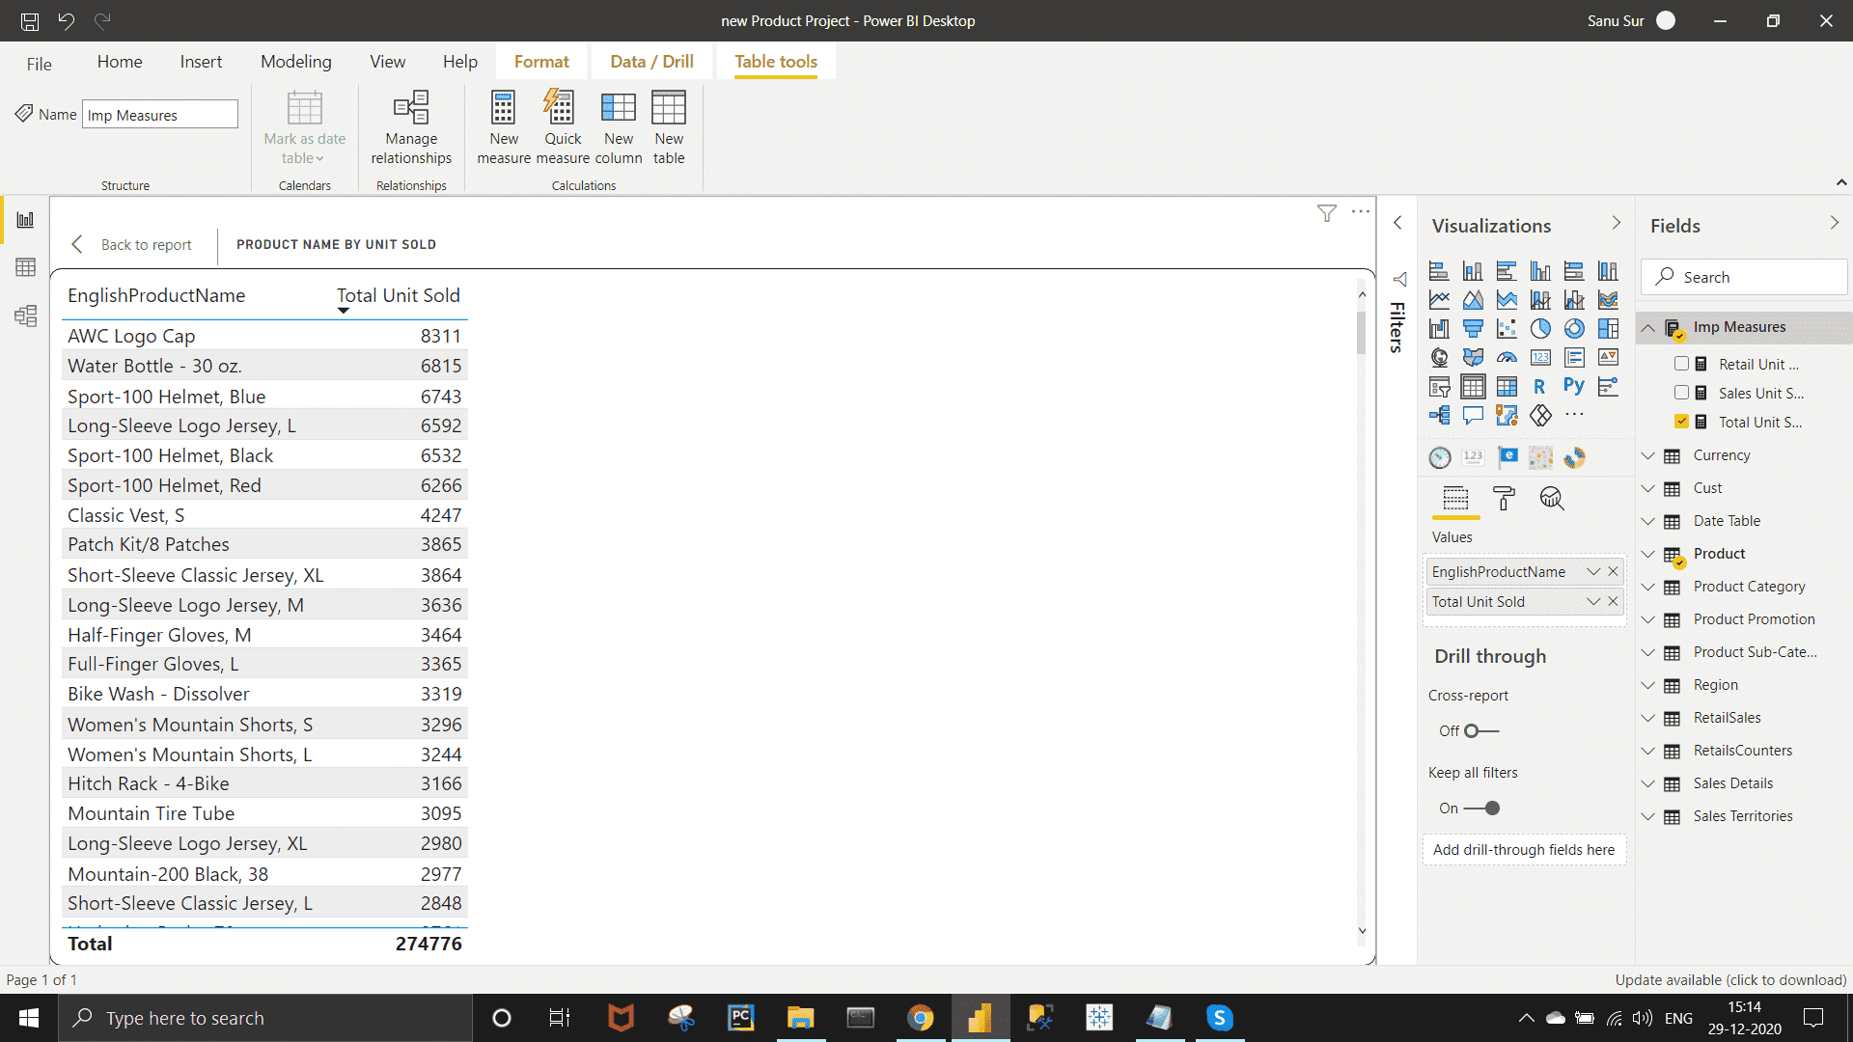

*Requirement :-*

• Top performing in subcategories in terms of Unit sold

*Approach :-*

Create a Funnel Chart >> Under visualization field bring Product[Subcategory] to Group field and Total Unit Sold under Value field.

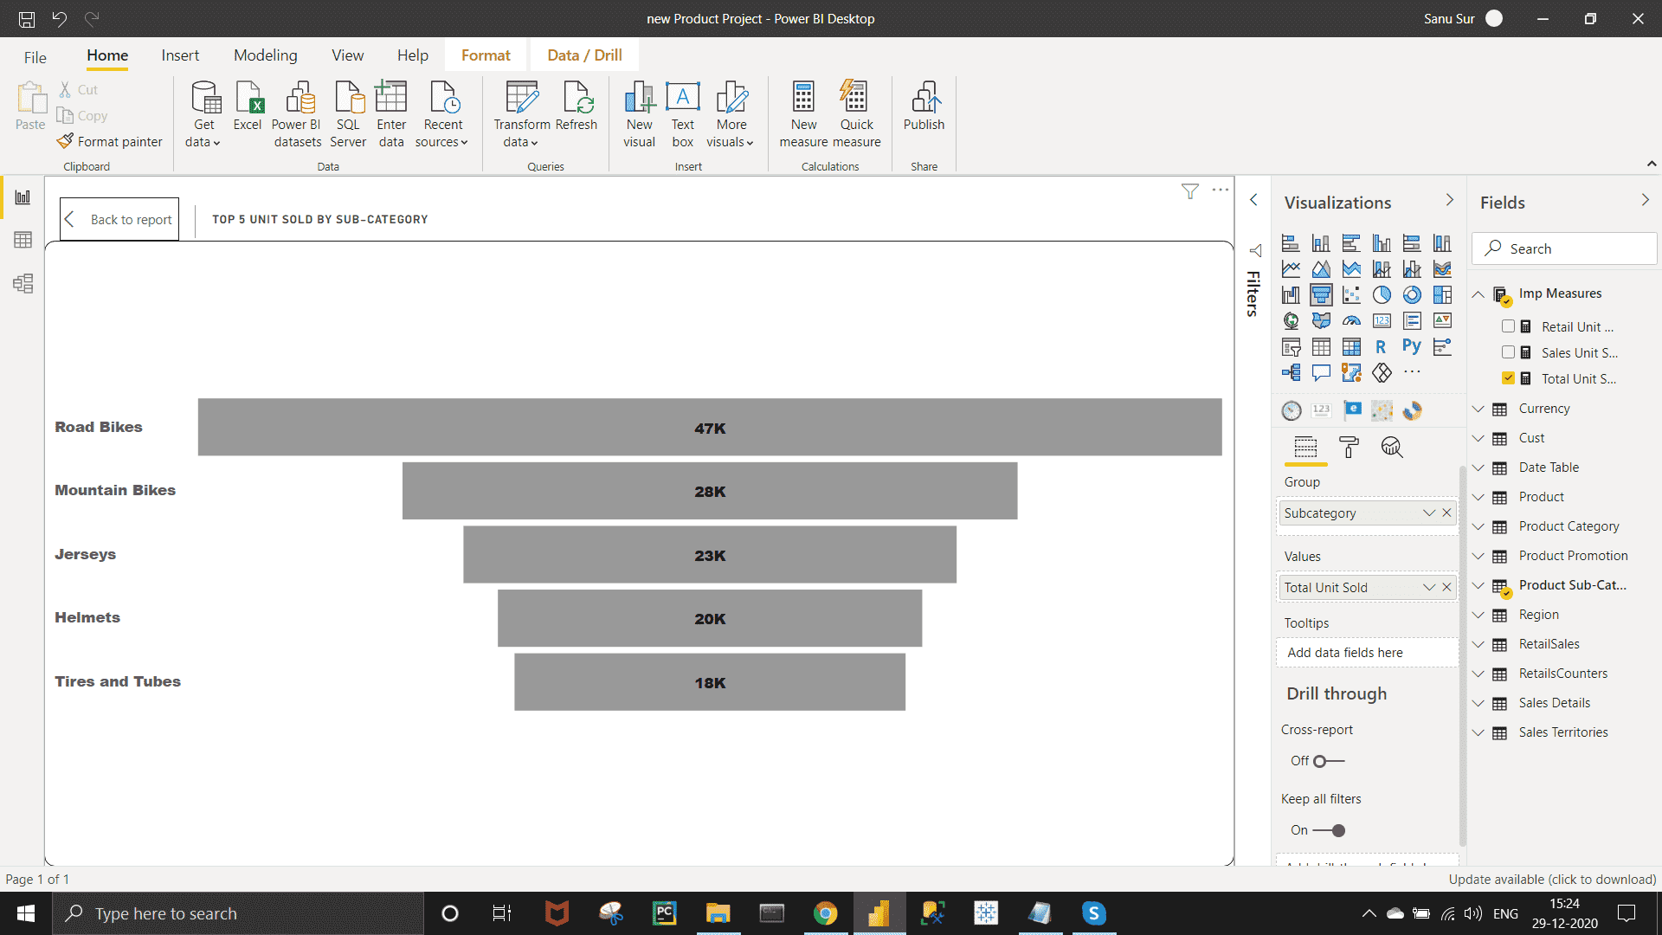

*Requirement :-*

• Unit sold in Promotion events in terms of reseller, no discount and Customers.

*Approach :-*

Create DoNut Chart >> Bring EnglishPromotionCategory under Legend field and Total Unit Sold Under  Value field.

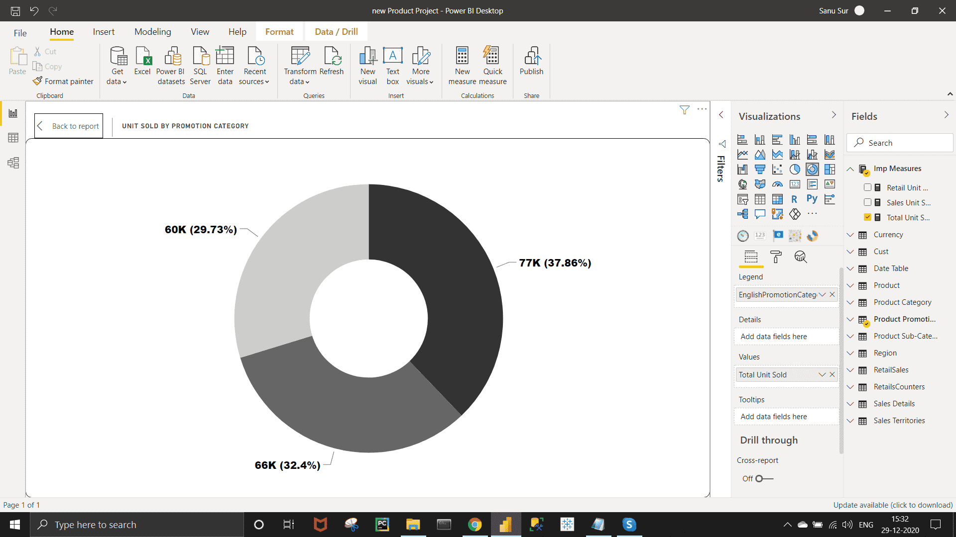

***Final Dashboard View :-***

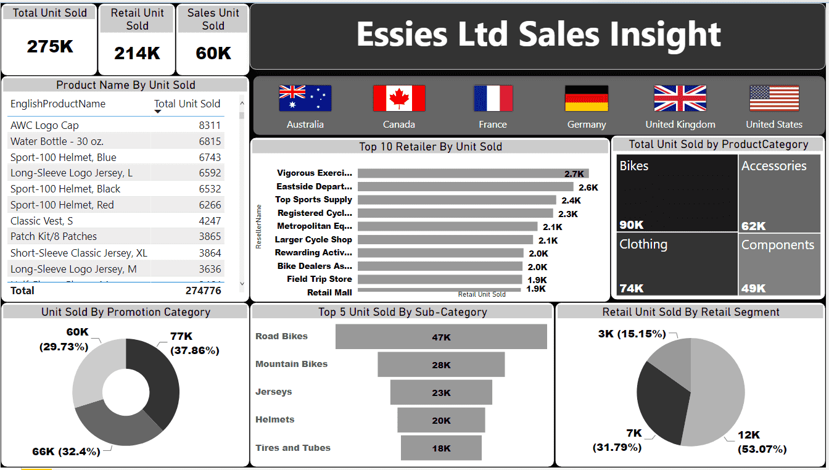

***Important Insights :-***

1. United States has highest sales in both Online and Retail .

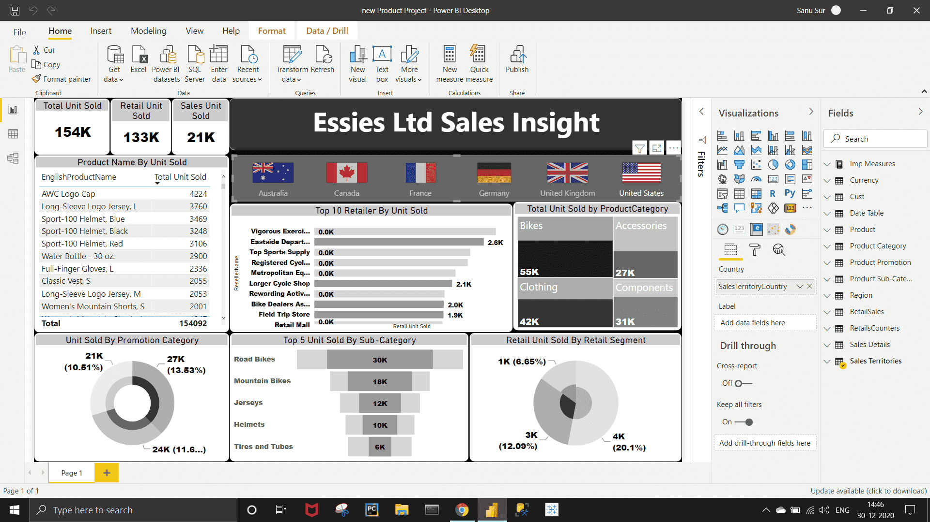

2. Bike has the highest amount of sales.  Under Bike category , Road Bikes and Mountain Bikes taking first two position respectively.

3. Jerseys has highest amount of sales under cloths category.

4.  Various Exercise Company form Canada has highest amount of unit sold in Retail category.

5. No Discount products are sold more during the promotion period.

6. AWC logo cap has highest amount of unit sold .